So you can’t afford to go abroad any more ☹ . You still want a holiday, but the sandy beaches of Sardegna are impossible now. So in spite of the lousy weather and vile food, you have decided to stay in England. But where will you go? Here are six options, you must talk about what you could do on a holiday like this, and agree with your friends where to go.

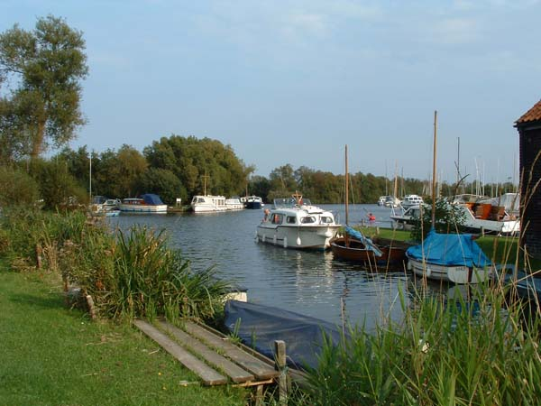  The Norfolk Broads  Spend a fortnight relaxing on a boat on the waterways of southern England, forget the time and forget your troubles as the water carries you into a new life free from stress and free from the hustle and bustle of city life. | 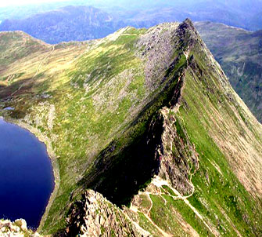  The Lake District  Stunning scenery, fresh air and friendly people. Climb our beautiful mountains or sail on our picture perfect lakes. Visit our unspoiled towns and traditional villages. There is something new for every day of the week, always with a warm welcome.
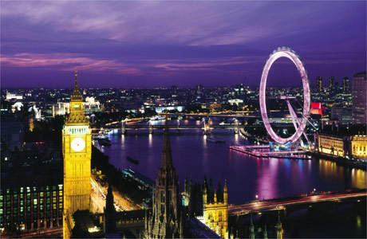  London  Fancy the excitement of a week in London? Do you want to see how the capital of fun changes at night? Do you want to see some of the best shops in the world, and visit some of the most famous attractions? Do you want to learn about life in one of its busiest places? If you do, come to London, you won’t regret it. | 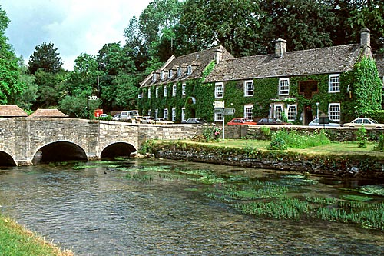  The Cotswolds  England’s prettiest area, the gentle hills and enchanting villages make the Cotswolds a dream for locals and tourists alike. Here you will experience a sense of peace, while you are able to continue living with people and getting on with your daily life. The Cotswolds have inspired poets and writers for centuries, could you be the next?
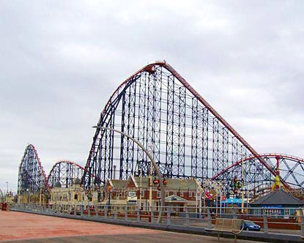  Blackpool  Europe’s premier and most popular pleasure beach awaits you. Come and experience a new form of excitement, let your adrenaline take you to a new place as you live life in the fast lane; roller coaster by day, disco by night. Blackpool is the most popular destination for Brits staying in Britain, how could you miss a party like this? | 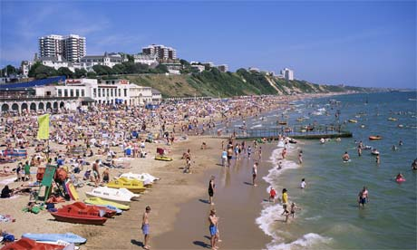  Bournemouth  Who needs the Costa del Sol when even England has miles and miles of sandy beaches and blue flag resorts? Why fly off to La Costa Smeralda when you can hire a deck chair on the gentle sands of the English south coast? Even where the average age of the citizens is close to 130, the youth of today can find fun like nowhere else in England.

